**Matlab code for MC-LAURIN power series:**

**INPUT:**

format compact

fprintf('to find "n" th power of "x" \n')

x=input('Enter value of x:\n (x must be greater than 1) \n');

n=input('Enter value of n:\n (n must be an integer) \n');

% To Convert equation to the form(1+x)^(n)

x=x-1;

allowable_error= input('Enter allowable error in percentage \n');

j=1;

power=1;

error=100;

i=1;

k=n;

while allowable_error < error

add=(x)^(i)/factorial(i)*k;

power=power+add;

n=n-1;

k=n*k;

i=i+1;

error=abs((add/power)*100);

end

fprintf('value of x^n =')

disp(power)

OUTPUT:

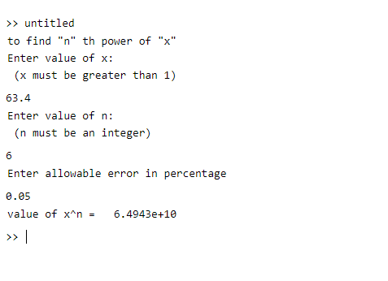

**MC-LAURIN Series in Matlab:**

**INPUT:**

syms x

y= sin(x);

n=10;

for i=1:n

tay(1,i)=y;

y=diff(y);

end

x=0;

tay=subs(tay);

syms x

for i=1:n

taylor(1,i)=(tay(1,i)/factorial(i-1))*x^(i-1);

end

TAYLOR=sum(taylor);

OUTPUT:

